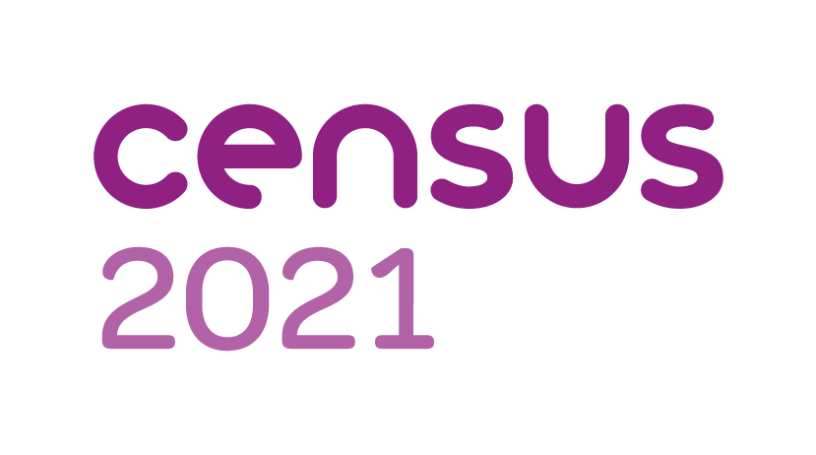
Ready, steady, census
The decennial census is almost upon us.
Households throughout Cumbria will soon be asked to take part in the nationwide survey of housing and the population. It has been carried out every decade since 1801, with the exception of 1941.
Information from the digital-first census will help decide how services are planned and funded in your local area. This could mean things like doctors’ surgeries, housing or new bus routes.
Households will receive a letter with a unique access code in the post, allowing them to complete their questionnaire online. Paper questionnaires will be available on request. Census day is March 21.
For more information, visit census.gov.uk.

Census 2021 will provide a snapshot of modern society
Households throughout Cumbria will soon be asked to take part in Census 2021.
The census is a once in a decade survey that gives us the most accurate estimate of all the people and households in England and Wales. It has been carried out every decade since 1801, with the exception of 1941.
It will be the first run predominantly online, with households receiving a letter with a unique access code, allowing them to complete the questionnaire on their computers, phones or tablets.
“A successful census will ensure everyone from local government to charities can put services and funding in the places where they are most needed,” Iain Bell, deputy national statistician at the Office for National Statistics, said.
“This could mean things like doctors’ surgeries, schools and new transport routes. That’s why it is so important everyone takes part and we have made it easier for people to do so online on any device, with help and paper questionnaires for those that need them.”
Census day will be on March 21, but households across the country will receive letters with online codes allowing them to take part from early March.
The census will include questions about your sex, age, work, health, education, household size and ethnicity. And, for the first time, there will be a question asking people whether they have served in the armed forces, as well as voluntary questions for those aged 16 and over on sexual orientation and gender identity.
Results will be available within 12 months, although personal records will be locked away for 100 years, kept safe for future generations.
For more information, visit census.gov.uk.

