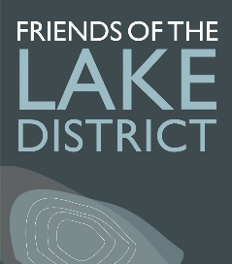
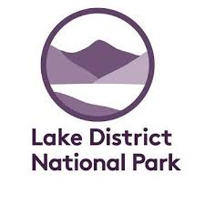
THE GREAT CUMBRIAN LITTER PICK 2020
Saturday 15th and Sunday 16th August
As the countryside has opened up again after the easing of lockdown, many people have been benefitting from the positive effects on mental and physical health our spectacular Lake District and Cumbrian landscapes undoubtedly bring.
And that’s great!
Sadly, as we are all too aware, a minority of people, many of whom are not regular visitors to the countryside have been what can only be described ‘trashing’ our much-loved environment. The ‘aftermath’ pictures have been truly shocking and there has been a groundswell of bewildered opinion as to the reasons why people would do this.
There’s no quick and easy solution but whilst we work on ways to research, educate and communicate more widely and effectively to change behaviours, there’s something really tangible that we CAN do right away; and we know many of you are itching to help and are already doing regular clean-ups.
The Great Cumbrian Litter Pick 2020 on Saturday 15th and Sunday 16th August is a partnership between Friends of the Lake District and the Lake District National Park.
It’s our chance show the rest of the country what our collective, community effort for Cumbria can achieve and how proud we are of our County.
Can you register to hold your own community litter pick either as an individual or with friends (max 6 per group)?
www.thegreatcumbrianlitterpick.org.uk

